Library Management System

**Introduction to the Library Management System**

The Library Management System (LMS) is a powerful and versatile software application designed to streamline and enhance the operations of libraries of all sizes. This system addresses the needs of librarians, members, and administrators by providing an integrated platform to manage a wide range of library activities efficiently. The LMS aims to facilitate smooth workflows, maintain comprehensive records, and improve user experiences.

Key Components of the Library Management System:

1. **Book Management**:
   * **Cataloging**: Books are cataloged with essential details such as title, ISBN, publisher, category, and authors. This organized catalog makes it easy for librarians to manage the collection and for members to find the books they need.
   * **Inventory Control**: Each book's quantity and location within the library are tracked to ensure accurate and up-to-date inventory records.
2. **Member Management**:
   * **Member Records**: The system maintains detailed records of all library members, including personal information, contact details, and membership dates. This helps in managing memberships and tracking member activity.
   * **Borrowing History**: The system keeps a history of books borrowed by each member, aiding in personalized service and efficient management.
3. **Loan Management**:
   * **Borrowing and Returning**: The LMS manages the loan process, recording details of books borrowed and returned by members. It ensures that due dates are tracked and overdue notifications are sent.
   * **Fine Calculation**: Overdue books can result in fines, which are automatically calculated and recorded by the system.
4. **Reservation System**:
   * **Book Reservations**: Members can reserve books that are currently on loan. The system notifies members when reserved books become available, ensuring fair and efficient access to popular titles.
5. **Review and Rating**:
   * **Member Reviews**: The LMS allows members to rate and review books they have read. This feature helps other members make informed decisions and fosters a sense of community within the library.
6. **Author and Publisher Management**:
   * **Author Information**: The system stores details about authors, including biographies and lists of their works, enriching the catalog with valuable information.
   * **Publisher Records**: Information about publishers is maintained to facilitate the acquisition process and improve catalog accuracy.
7. **Category Management**:
   * **Organizing Books**: Books are categorized into different genres and topics, making it easier for members to browse and discover new titles of interest.
8. **Fine Management**:
   * **Handling Overdue Books**: The system tracks overdue books and automatically generates fines based on library policies. This ensures timely returns and maintains order within the library.

**Benefits of the Library Management System**

* **Efficiency**: Automates routine tasks such as cataloging, loans, and fine calculations, freeing up librarians to focus on more strategic activities.
* **Accuracy**: Maintains precise records of inventory, loans, and member activity, reducing errors and improving accountability.
* **User Experience**: Enhances the user experience by providing easy access to book information, reviews, and reservation capabilities.
* **Resource Management**: Helps in efficient management of library resources, ensuring that books are available when needed and that the library operates smoothly.
* **Community Engagement**: Fosters a sense of community by allowing members to share reviews and recommendations.

Overall, the Library Management System is an essential tool for modern libraries, providing the technological backbone needed to manage operations effectively, engage with members, and support the library's mission of promoting knowledge and literacy.

Library Management System Project Report

Table of Contents

Introduction

System Requirements

Design and Architecture

ER Diagram

Entities and Relationships

Implementation

Testing and Validation

Conclusion

Future Enhancements

References

1. Introduction

The Library Management System (LMS) is a software application designed to manage library operations effectively and efficiently. This system aids in managing book cataloging, member registration, loan processing, reservations, reviews, fines, and inventory control. The primary objective is to streamline library processes, ensuring a seamless experience for both librarians and members.

2. System Requirements

Hardware Requirements

Server with adequate processing power and memory

Client machines with internet access

Barcode scanners for book and member ID processing

Printers for printing receipts and notices

Software Requirements

Operating System: Windows/Linux/MacOS

Database Management System: MySQL/PostgreSQL

Web Server: Apache/Nginx

Programming Languages: Java/PHP/Python

Frontend Technologies: HTML, CSS, JavaScript

3. Design and Architecture

ER Diagram

The ER (Entity-Relationship) diagram is a visual representation of the entities in the Library Management System and their relationships. Below is a detailed breakdown of each entity and their attributes, along with the relationships between them.

Entities and Attributes

Book

BookID (Primary Key)

Title

ISBN

PublicationYear

Pages

Language

Summary

PublisherID (Foreign Key)

CategoryID (Foreign Key)

Member

MemberID (Primary Key)

Name

Address

Phone

Email

MembershipDate

ExpiryDate

Loan

LoanID (Primary Key)

BookID (Foreign Key)

MemberID (Foreign Key)

LoanDate

DueDate

ReturnDate

FineID (Foreign Key)

Reservation

ReservationID (Primary Key)

BookID (Foreign Key)

MemberID (Foreign Key)

ReservationDate

Status

Author

AuthorID (Primary Key)

Name

Bio

Publisher

PublisherID (Primary Key)

Name

Address

Phone

Email

Category

CategoryID (Primary Key)

Name

Description

Review

ReviewID (Primary Key)

BookID (Foreign Key)

MemberID (Foreign Key)

Rating

Comment

ReviewDate

Fine

FineID (Primary Key)

Amount

FineDate

Description

Inventory

InventoryID (Primary Key)

BookID (Foreign Key)

Quantity

Location

Relationships

Book - Author: Many-to-Many (A book can have multiple authors, and an author can write multiple books)

Book - Publisher: Many-to-One (A book is published by one publisher, but a publisher can publish many books)

Book - Category: Many-to-One (A book belongs to one category, but a category can include many books)

Book - Review: One-to-Many (A book can have multiple reviews, but a review is for one book)

Member - Loan: One-to-Many (A member can have multiple loans, but a loan is linked to one member)

Member - Reservation: One-to-Many (A member can make multiple reservations, but a reservation is made by one member)

Loan - Fine: One-to-One (A loan can result in one fine, and a fine is associated with one loan)

Book - Loan: One-to-Many (A book can be loaned multiple times, but a loan is for one book)

Book - Reservation: One-to-Many (A book can be reserved multiple times, but a reservation is for one book)

Book - Inventory: One-to-One (Each book in the inventory is a specific copy of a book)

4. Implementation

The Library Management System is implemented using a three-tier architecture consisting of the presentation layer, the business logic layer, and the data access layer.

Presentation Layer: The user interface, developed using HTML, CSS, and JavaScript, provides a seamless interaction for librarians and members.

Business Logic Layer: Implemented using Java/PHP/Python, this layer handles the core operations of the LMS including processing loans, reservations, and managing inventory.

Data Access Layer: Using MySQL/PostgreSQL, this layer interacts with the database to perform CRUD (Create, Read, Update, Delete) operations on the data.

5. Testing and Validation

The system undergoes rigorous testing to ensure all functionalities work as expected.

Unit Testing: Individual components are tested for correctness.

Integration Testing: Ensures that different modules of the system work together seamlessly.

System Testing: The complete system is tested for compliance with the requirements.

User Acceptance Testing (UAT): End-users test the system to validate its usability and functionality.

6. Conclusion

The Library Management System is a comprehensive solution for managing library resources efficiently. It simplifies the cataloging process, streamlines loan and reservation management, handles fines accurately, and provides insightful reviews. The system enhances the overall user experience for both librarians and members, ensuring efficient library operations.

7. Future Enhancements

Mobile Application: Developing a mobile app for better accessibility and convenience.

Advanced Search Features: Implementing AI-based search algorithms for improved book searches.

Integration with E-books: Allowing members to borrow and read e-books directly from the system.

Enhanced Reporting: Adding more advanced reporting features for better insights and analytics.

8. References

Java/PHP/Python programming tutorials

HTML, CSS, and JavaScript documentation

MySQL/PostgreSQL official documentation

Abstract:

This project report details the design and implementation of a Library Management System (LMS), an automated system developed to manage the diverse functions of a library effectively. The LMS is structured to handle book cataloging, member management, loan processing, reservations, reviews, fines, and inventory control. The core objective is to streamline the administrative processes, providing a seamless interaction between the library staff and members.

The system comprises several key entities:

Book: Represents the collection of books available in the library.

Member: Captures the details of library members.

Loan: Tracks the borrowing and returning of books by members.

Reservation: Manages the reservations placed by members for specific books.

Author: Stores information about the authors of books.

Publisher: Maintains details of the publishers.

Category: Organizes books into different categories or genres.

Review: Allows members to provide feedback and rate books.

Fine: Records fines incurred by members for overdue or lost books.

Inventory: Keeps track of the physical copies of books in the library.

The ER (Entity-Relationship) diagram of the LMS highlights the relationships between these entities, providing a clear visualization of how data is structured and interrelated within the system. This report delves into the system requirements, design, implementation, and testing phases of the project, ensuring a robust and user-friendly solution.

The LMS is designed to enhance operational efficiency, reduce manual errors, and provide a better user experience for both library staff and members. With future enhancements such as a mobile application, AI-based search functionalities, integration with e-books, and advanced reporting features, the LMS aims to remain a cutting-edge tool in library management.

ER Diagram

To accompany this abstract, the following entities and their relationships are part of the ER diagram for the Library Management System:

Entities and Attributes

Book

Attributes: BookID (Primary Key), Title, ISBN, PublicationYear, Pages, Language, Summary, PublisherID (Foreign Key), CategoryID (Foreign Key)

Member

Attributes: MemberID (Primary Key), Name, Address, Phone, Email, MembershipDate, ExpiryDate

Loan

Attributes: LoanID (Primary Key), BookID (Foreign Key), MemberID (Foreign Key), LoanDate, DueDate, ReturnDate, FineID (Foreign Key)

Reservation

Attributes: ReservationID (Primary Key), BookID (Foreign Key), MemberID (Foreign Key), ReservationDate, Status

Author

Attributes: AuthorID (Primary Key), Name, Bio

Publisher

Attributes: PublisherID (Primary Key), Name, Address, Phone, Email

Category

Attributes: CategoryID (Primary Key), Name, Description

Review

Attributes: ReviewID (Primary Key), BookID (Foreign Key), MemberID (Foreign Key), Rating, Comment, ReviewDate

Fine

Attributes: FineID (Primary Key), Amount, FineDate, Description

Inventory

Attributes: InventoryID (Primary Key), BookID (Foreign Key), Quantity, Location

Relationships

Book - Author: Many-to-Many (A book can have multiple authors, and an author can write multiple books)

Book - Publisher: Many-to-One (A book is published by one publisher, but a publisher can publish many books)

Book - Category: Many-to-One (A book belongs to one category, but a category can include many books)

Book - Review: One-to-Many (A book can have multiple reviews, but a review is for one book)

Member - Loan: One-to-Many (A member can have multiple loans, but a loan is linked to one member)

Member - Reservation: One-to-Many (A member can make multiple reservations, but a reservation is made by one member)

Loan - Fine: One-to-One (A loan can result in one fine, and a fine is associated with one loan)

Book - Loan: One-to-Many (A book can be loaned multiple times, but a loan is for one book)

Book - Reservation: One-to-Many (A book can be reserved multiple times, but a reservation is for one book)

Book - Inventory: One-to-One (Each book in the inventory is a specific copy of a book)

Functional Requirements:

A Library Management System (LMS) needs to fulfill various functions to manage library operations efficiently. The following are the detailed functional requirements for the LMS, organized by entity:

Book

Add Book

Librarian can add new books to the library’s collection.

Attributes: Title, ISBN, PublicationYear, Pages, Language, Summary, PublisherID, CategoryID.

Update Book

Librarian can update book information.

Attributes: Title, ISBN, PublicationYear, Pages, Language, Summary, PublisherID, CategoryID.

Delete Book

Librarian can remove books from the library’s collection.

Search Book

Members and librarians can search for books using various criteria such as title, author, ISBN, category, and publisher.

Member

Register Member

Librarian can register new members.

Attributes: Name, Address, Phone, Email, MembershipDate, ExpiryDate.

Update Member

Librarian can update member information.

Attributes: Name, Address, Phone, Email, MembershipDate, ExpiryDate.

Delete Member

Librarian can delete member records from the system.

Search Member

Librarians can search for members using various criteria such as name, member ID, and email.

Loan

Issue Loan

Librarian can issue books to members.

Attributes: BookID, MemberID, LoanDate, DueDate.

Return Loan

Librarian can record the return of books.

Attributes: LoanID, ReturnDate.

Check Loan Status

Librarian and members can check the status of a loan.

Attributes: LoanID, DueDate, ReturnDate, FineID.

Overdue Loans

The system can generate a list of overdue loans and calculate fines.

Reservation

Place Reservation

Members can place a reservation on books that are currently checked out.

Attributes: BookID, MemberID, ReservationDate, Status.

Cancel Reservation

Members and librarians can cancel reservations.

Check Reservation Status

Members can check the status of their reservations.

Author

Add Author

Librarian can add new authors to the system.

Attributes: Name, Bio.

Update Author

Librarian can update author information.

Attributes: Name, Bio.

Delete Author

Librarian can delete author records.

Publisher

Add Publisher

Librarian can add new publishers to the system.

Attributes: Name, Address, Phone, Email.

Update Publisher

Librarian can update publisher information.

Attributes: Name, Address, Phone, Email.

Delete Publisher

Librarian can delete publisher records.

Category

Add Category

Librarian can add new categories to classify books.

Attributes: Name, Description.

Update Category

Librarian can update category information.

Attributes: Name, Description.

Delete Category

Librarian can delete categories.

Review

Add Review

Members can add reviews for books they have read.

Attributes: BookID, MemberID, Rating, Comment, ReviewDate.

Update Review

Members can update their reviews.

Attributes: Rating, Comment.

Delete Review

Members can delete their reviews.

Fine

Calculate Fine

The system calculates fines for overdue books.

Attributes: LoanID, Amount, FineDate, Description.

Pay Fine

Members can pay fines.

Check Fine Status

Members and librarians can check the status of fines.

Inventory

Track Inventory

The system tracks the quantity and location of books.

Attributes: BookID, Quantity, Location.

Update Inventory

Librarian can update inventory records.

Attributes: BookID, Quantity, Location.

General System Requirements

User Authentication and Authorization

The system supports different roles (e.g., librarian, member) with appropriate access controls.

Notification System

The system sends notifications for overdue books, reservation availability, and other alerts.

Reporting and Analytics

The system generates reports on book loans, member activity, overdue books, fines collected, etc.

Backup and Recovery

The system regularly backs up data and supports data recovery in case of failure.

ER-Diagram:

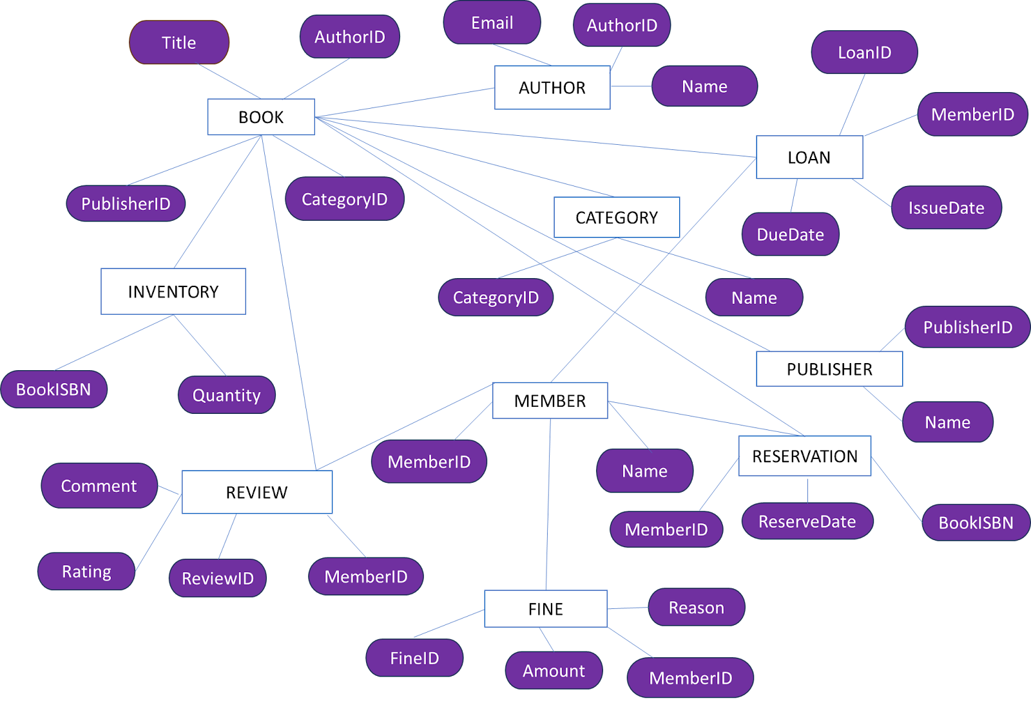

Class/UML attributes & methods:

# **LOAN**

# Attributes:

* -loanId: int
* -bookId: int
* -memberId: int
* -issueDate: Date
* -dueDate: Date
* -returnDate: Date
* -status: String

Methods:

* +issueBook()

+returnBook()

* +checkLoanStatus()

# **RESERVATION**

Attributes:

* -reservationId: int
* -bookId: int
* -memberId: int
* -reservationDate: Date
* -status: String
* · Methods:
  + +reserveBook()
  + +cancelReservation()
  + +checkReservationStatus()

# **AUTHOR**

Attributes:

* -authorId: int
* -name: String
* -biography: String

· Methods:

* + +addAuthor()
  + +updateAuthorDetails()

# **PUBLISHER**

# 

Attributes:

* -publisherId: int
* -name: String
* -address: String
* · Methods:
  + +addPublisher()
  + +updatePublisherDetails()

# **CATEGORY**

· Attributes:

* -categoryId: int
* -categoryName: String

Methods:

* +addCategory()
* +updateCategoryDetails()

# **REVIEW**

Attributes:

* -reviewId: int
* -bookId: int
* -memberId: int
* -rating: int
* -comment: String
* -reviewDate: Date

Methods:

* +addReview()
* +updateReview()
* +deleteReview()

# **FINE**

· Attributes:

* -fineId: int
* -loanId: int
* -amount: double
* -paymentDate: Date

Methods:

* +calculateFine()
* +payFine()
* +checkFineStatus()

# **BOOK**

· Attributes:

* -bookId: int
* -title: String
* -ISBN: String
* -publicationYear: int
* -copiesAvailable: int
* · Methods:
  + +addBook()
  + +RemoveBook()
  + +updateBookDetails()
  + +checkAvailability()

# **MEMBER**

Attributes:

* -memberId: int
* -name: String
* -address: String
* -phoneNumber: String
* -email: String
* -membershipDate: Date
* · Methods:
  + +registerMember()
  + +updateMemberDetails()
  + +viewBorrowedBooks()

# **INVENTORY**

· Attributes:

* -inventoryId: int
* -bookId: int
* -totalCopies: int
* -availableCopies: int

Methods:

* +updateInventory()
* +checkInventoryStatus()

Quries to create database:

CREATE TABLE Book ( BookID INT AUTO_INCREMENT PRIMARY KEY, Title VARCHAR(255) NOT NULL, ISBN VARCHAR(13) UNIQUE NOT NULL, AuthorID INT,PublisherID INT,CategoryID INT,Quantity INT NOT NULL,Availability BOOLEAN NOT NULL,FOREIGN KEY (AuthorID) REFERENCES Author(AuthorID), FOREIGN KEY (PublisherID) REFERENCES Publisher(PublisherID), FOREIGN KEY (CategoryID) REFERENCES Category(CategoryID));

INSERT INTO Book (Title, ISBN, AuthorID, PublisherID, CategoryID, Quantity, Availability) VALUES

('The Great Gatsby', '9780743273565', 1, 1, 1, 100, true),

('To Kill a Mockingbird', '9780061120084', 2, 1, 1, 150, true);

CREATE TABLE Member ( MemberID INT AUTO_INCREMENT PRIMARY KEY,Name VARCHAR(255) NOT NULL,Email VARCHAR(255) UNIQUE NOT NULL,Phone VARCHAR(15),Address TEXT);

INSERT INTO Member (Name, Email, Phone, Address) VALUES ('John Doe', 'john@example.com', '123-456-7890', '123 Main St'),('Jane Smith', 'jane@example.com', '987-654-3210', '456 Elm St');

CREATE TABLE Loan ( LoanID INT AUTO_INCREMENT PRIMARY KEY,BookID INT,MemberID INT,LoanDate DATE,DueDate DATE,ReturnDate DATE,FOREIGN KEY (BookID) REFERENCES Book(BookID),FOREIGN KEY (MemberID) REFERENCES Member(MemberID));

INSERT INTO Loan (BookID, MemberID, LoanDate, DueDate, ReturnDate) VALUES (1, 1, '2024-05-01', '2024-05-15', NULL),(2, 2, '2024-05-02', '2024-05-16', NULL);

CREATE TABLE Reservation ( ReservationID INT AUTO_INCREMENT PRIMARY KEY,BookID INT,MemberID INT,ReservationDate DATE,Status ENUM('Pending', 'Active', 'Expired'),FOREIGN KEY (BookID) REFERENCES Book(BookID),FOREIGN KEY (MemberID) REFERENCES Member(MemberID));

INSERT INTO Reservation (BookID, MemberID, ReservationDate, Status) VALUES (1, 1, '2024-05-01', 'Pending'),(2, 2, '2024-05-02', 'Pending');